Monaco
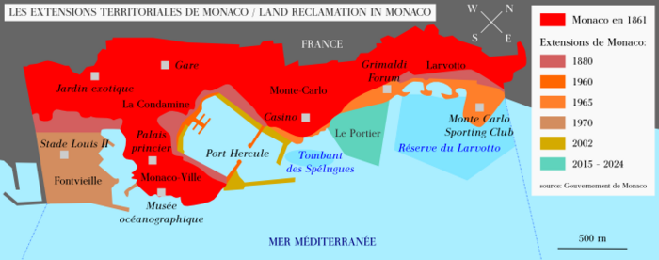
Chronology
237 BC - 476 AD Part of Roman Empire.
476 - 493 Part of the kingdom of Odovacar (see Italy).
493 - 553 Ostrogothic rule (see Italy).
553 - 568 Part of Eastern Roman (Byzantine) Empire.
568 - c.760 Lombard (Langobard) rule (see Italy).
c.760 - Aug 843 Part of Frankish kingdom.
Aug 843 - 879 Part of Lotharingia.
879 - 933 Part of Burgundy (with county of Provence).
933 - 6 Sep 1032 Part of the Burgundian Kingdom (Arelat).
6 Sep 1032 Burgundy (and Monaco with it) inherited by the
Emperor of Germany (Holy Roman Empire).
16 Aug 1174 Sold to Genoa by Raimond VI Count of Toulouse
(claimant to County of Provence).
30 May 1191 Holy Roman Emperor Heinrich VI grants suzerainty
over the area to Genoa (repeating and expanding on
9 Jun 1162 grant of coast; effective 2 Jul 1191,
confirmed 4 Oct 1220).
10 Jun 1215 First stone of the fortress is laid.
22 Jul 1262 Genoese possession confirmed by count of Provence.
8 Jan 1297 Francesco and Raniero Grimaldi seize the fortress
(occupied by Guelphs during war).
4 May 1301 - 20 Sep 1331 Genoese rule (by convention of 10 Apr 1301).
19 Nov 1346 Grimaldi acquire Mentone (Menton).
2 Jan 1355 Grimaldi acquire Roccabruna (Roquebrune).
15 Aug 1357 - 11 May 1397 Genoese rule.
19 Dec 1395 Failed attempt to regain Monaco by Boglio (Beuil)
branch of the Grimaldi dynasty.
5 Nov 1402 - May? 1419 Genoese rule.
6 Oct 1428 - 18 Mar 1436 Duchy of Milan rule.
14 Jan 1498 - 7 Jun 1524 Protectorate of France (confirmed 11 Jun 1507; under
French suzerainty 6 Mar 1509 - 20 Feb 1512).
10 Dec 1506 - 22 Mar 1507 Under siege by Genoa.
20 Feb 1512 France recognizes sovereignty of Monaco, French
protectorate remains.
7 Jun 1524 - 17 Nov 1641 Spanish protectorate (ratified by Spain 5 Nov 1524;
ratified by Monaco 10 Apr 1525).
11 Nov 1605 - 17 Nov 1641 Spanish forces station in Monaco.
14 Sep 1641 Principality of Monaco (Principato di Monaco/
Principauté de Monaco); sovereign 8 Jun 1688,
under protectorate of France by Treaty of Péronne.
17 Nov 1641 Spanish forces evicted (replaced by French forces
24 Nov 1641).
1641 Monaco effectively ceases to be part of the Holy
Roman Empire.
20 Jul 1642 Italian grants confiscated (in consequence of
termination of Spanish protectorate).
23 Dec 1678 First constitution promulgated.
31 Dec 1688 Monaco recognized as prince étranger by France.
19 Jan 1793 National Convention declares the Grimaldi dynasty
deposed; République de Monaco.
14 Feb 1793 Law on incorporation of Monaco (and other lands)
into France (Loi qui réunit à la République
Française la principaute de Monaco, etc) in Paris.
19 Feb 1793 The use of French was made compulsory.
24 Feb 1793 - 1 Mar 1793 Occupied by France.
24 Feb 1793 - 30 May 1814 Annexed to France (by 14 Feb 1793 decree), part of
département Alpes-Maritimes (see Italian states).
12 May 1800 - 31 May 1800 Austro-Sardinian occupation.
17 Apr 1814 Provisional government established (by revolt).
17 May 1814 - 17 Jun 1814 Austrian occupation.
30 May 1814 Principality of Monaco (Principauté de Monaco)
(restored)(by U.K., Austria, Russia, Prussia,
France by peace Treaty of Paris, ratified 31 May
1814; effective on 17 Jun 1814).
13 Mar 1815 - 20 Nov 1815 Anglo-Sardinian occupation.
20 Nov 1815 French protectorate transferred to Sardinia-
Piedmont.
8 Nov 1817 - 18 Jul 1860 Protectorate of Sardinia-Piedmont.
10 Nov 1849 Menton and Roquebrune annexed by Sardinia-Piedmont.
18 Jul 1860 - 24 Oct 2002 Protectorate of France (confirmed 17 Jul 1918).
16 Nov 1942 - 9 Sep 1943 Occupied by Italy.
9 Sep 1943 - 3 Sep 1944 Occupied by Germany.

INCLUDEPICTURE "http://t0.gstatic.com/images?q=tbn:ANd9GcTDT1jpfS6n_Y4NmsXFnf0dV2uAk854tEHeOSaIXPxUCt7qxHu5xaSaZA" \* MERGEFORMATINET INCLUDEPICTURE "http://t0.gstatic.com/images?q=tbn:ANd9GcTDT1jpfS6n_Y4NmsXFnf0dV2uAk854tEHeOSaIXPxUCt7qxHu5xaSaZA" \* MERGEFORMATINET INCLUDEPICTURE "http://t0.gstatic.com/images?q=tbn:ANd9GcTDT1jpfS6n_Y4NmsXFnf0dV2uAk854tEHeOSaIXPxUCt7qxHu5xaSaZA" \* MERGEFORMATINET INCLUDEPICTURE "http://t0.gstatic.com/images?q=tbn:ANd9GcTDT1jpfS6n_Y4NmsXFnf0dV2uAk854tEHeOSaIXPxUCt7qxHu5xaSaZA" \* MERGEFORMATINET INCLUDEPICTURE "http://t0.gstatic.com/images?q=tbn:ANd9GcTDT1jpfS6n_Y4NmsXFnf0dV2uAk854tEHeOSaIXPxUCt7qxHu5xaSaZA" \* MERGEFORMATINET INCLUDEPICTURE "http://t0.gstatic.com/images?q=tbn:ANd9GcTDT1jpfS6n_Y4NmsXFnf0dV2uAk854tEHeOSaIXPxUCt7qxHu5xaSaZA" \* MERGEFORMATINET INCLUDEPICTURE "http://t0.gstatic.com/images?q=tbn:ANd9GcTDT1jpfS6n_Y4NmsXFnf0dV2uAk854tEHeOSaIXPxUCt7qxHu5xaSaZA" \* MERGEFORMATINET INCLUDEPICTURE "http://t0.gstatic.com/images?q=tbn:ANd9GcTDT1jpfS6n_Y4NmsXFnf0dV2uAk854tEHeOSaIXPxUCt7qxHu5xaSaZA" \* MERGEFORMATINET INCLUDEPICTURE "http://t0.gstatic.com/images?q=tbn:ANd9GcTDT1jpfS6n_Y4NmsXFnf0dV2uAk854tEHeOSaIXPxUCt7qxHu5xaSaZA" \* MERGEFORMATINET INCLUDEPICTURE "http://t0.gstatic.com/images?q=tbn:ANd9GcTDT1jpfS6n_Y4NmsXFnf0dV2uAk854tEHeOSaIXPxUCt7qxHu5xaSaZA" \* MERGEFORMATINET INCLUDEPICTURE "http://t0.gstatic.com/images?q=tbn:ANd9GcTDT1jpfS6n_Y4NmsXFnf0dV2uAk854tEHeOSaIXPxUCt7qxHu5xaSaZA" \* MERGEFORMATINET INCLUDEPICTURE "http://t0.gstatic.com/images?q=tbn:ANd9GcTDT1jpfS6n_Y4NmsXFnf0dV2uAk854tEHeOSaIXPxUCt7qxHu5xaSaZA" \* MERGEFORMATINET INCLUDEPICTURE "http://t0.gstatic.com/images?q=tbn:ANd9GcTDT1jpfS6n_Y4NmsXFnf0dV2uAk854tEHeOSaIXPxUCt7qxHu5xaSaZA" \* MERGEFORMATINET INCLUDEPICTURE "http://t0.gstatic.com/images?q=tbn:ANd9GcTDT1jpfS6n_Y4NmsXFnf0dV2uAk854tEHeOSaIXPxUCt7qxHu5xaSaZA" \* MERGEFORMATINET INCLUDEPICTURE "http://t0.gstatic.com/images?q=tbn:ANd9GcTDT1jpfS6n_Y4NmsXFnf0dV2uAk854tEHeOSaIXPxUCt7qxHu5xaSaZA" \* MERGEFORMATINET INCLUDEPICTURE "http://t0.gstatic.com/images?q=tbn:ANd9GcTDT1jpfS6n_Y4NmsXFnf0dV2uAk854tEHeOSaIXPxUCt7qxHu5xaSaZA" \* MERGEFORMATINET INCLUDEPICTURE "http://t0.gstatic.com/images?q=tbn:ANd9GcTDT1jpfS6n_Y4NmsXFnf0dV2uAk854tEHeOSaIXPxUCt7qxHu5xaSaZA" \* MERGEFORMATINET INCLUDEPICTURE "http://t0.gstatic.com/images?q=tbn:ANd9GcTDT1jpfS6n_Y4NmsXFnf0dV2uAk854tEHeOSaIXPxUCt7qxHu5xaSaZA" \* MERGEFORMATINET INCLUDEPICTURE "http://t0.gstatic.com/images?q=tbn:ANd9GcTDT1jpfS6n_Y4NmsXFnf0dV2uAk854tEHeOSaIXPxUCt7qxHu5xaSaZA" \* MERGEFORMATINET INCLUDEPICTURE "http://t0.gstatic.com/images?q=tbn:ANd9GcTDT1jpfS6n_Y4NmsXFnf0dV2uAk854tEHeOSaIXPxUCt7qxHu5xaSaZA" \* MERGEFORMATINET INCLUDEPICTURE "http://t0.gstatic.com/images?q=tbn:ANd9GcTDT1jpfS6n_Y4NmsXFnf0dV2uAk854tEHeOSaIXPxUCt7qxHu5xaSaZA" \* MERGEFORMATINET INCLUDEPICTURE "http://t0.gstatic.com/images?q=tbn:ANd9GcTDT1jpfS6n_Y4NmsXFnf0dV2uAk854tEHeOSaIXPxUCt7qxHu5xaSaZA" \* MERGEFORMATINET INCLUDEPICTURE "http://t0.gstatic.com/images?q=tbn:ANd9GcTDT1jpfS6n_Y4NmsXFnf0dV2uAk854tEHeOSaIXPxUCt7qxHu5xaSaZA" \* MERGEFORMATINET INCLUDEPICTURE "http://t0.gstatic.com/images?q=tbn:ANd9GcTDT1jpfS6n_Y4NmsXFnf0dV2uAk854tEHeOSaIXPxUCt7qxHu5xaSaZA" \* MERGEFORMATINET INCLUDEPICTURE "http://t0.gstatic.com/images?q=tbn:ANd9GcTDT1jpfS6n_Y4NmsXFnf0dV2uAk854tEHeOSaIXPxUCt7qxHu5xaSaZA" \* MERGEFORMATINET INCLUDEPICTURE "http://t0.gstatic.com/images?q=tbn:ANd9GcTDT1jpfS6n_Y4NmsXFnf0dV2uAk854tEHeOSaIXPxUCt7qxHu5xaSaZA" \* MERGEFORMATINET INCLUDEPICTURE "http://t0.gstatic.com/images?q=tbn:ANd9GcTDT1jpfS6n_Y4NmsXFnf0dV2uAk854tEHeOSaIXPxUCt7qxHu5xaSaZA" \* MERGEFORMATINET INCLUDEPICTURE "http://t0.gstatic.com/images?q=tbn:ANd9GcTDT1jpfS6n_Y4NmsXFnf0dV2uAk854tEHeOSaIXPxUCt7qxHu5xaSaZA" \* MERGEFORMATINET INCLUDEPICTURE "http://t0.gstatic.com/images?q=tbn:ANd9GcTDT1jpfS6n_Y4NmsXFnf0dV2uAk854tEHeOSaIXPxUCt7qxHu5xaSaZA" \* MERGEFORMATINET INCLUDEPICTURE "http://t0.gstatic.com/images?q=tbn:ANd9GcTDT1jpfS6n_Y4NmsXFnf0dV2uAk854tEHeOSaIXPxUCt7qxHu5xaSaZA" \* MERGEFORMATINET INCLUDEPICTURE "http://t0.gstatic.com/images?q=tbn:ANd9GcTDT1jpfS6n_Y4NmsXFnf0dV2uAk854tEHeOSaIXPxUCt7qxHu5xaSaZA" \* MERGEFORMATINET INCLUDEPICTURE "http://t0.gstatic.com/images?q=tbn:ANd9GcTDT1jpfS6n_Y4NmsXFnf0dV2uAk854tEHeOSaIXPxUCt7qxHu5xaSaZA" \* MERGEFORMATINET INCLUDEPICTURE "http://t0.gstatic.com/images?q=tbn:ANd9GcTDT1jpfS6n_Y4NmsXFnf0dV2uAk854tEHeOSaIXPxUCt7qxHu5xaSaZA" \* MERGEFORMATINET INCLUDEPICTURE "http://t0.gstatic.com/images?q=tbn:ANd9GcTDT1jpfS6n_Y4NmsXFnf0dV2uAk854tEHeOSaIXPxUCt7qxHu5xaSaZA" \* MERGEFORMATINET INCLUDEPICTURE "http://t0.gstatic.com/images?q=tbn:ANd9GcTDT1jpfS6n_Y4NmsXFnf0dV2uAk854tEHeOSaIXPxUCt7qxHu5xaSaZA" \* MERGEFORMATINET INCLUDEPICTURE "http://t0.gstatic.com/images?q=tbn:ANd9GcTDT1jpfS6n_Y4NmsXFnf0dV2uAk854tEHeOSaIXPxUCt7qxHu5xaSaZA" \* MERGEFORMATINET INCLUDEPICTURE "http://t0.gstatic.com/images?q=tbn:ANd9GcTDT1jpfS6n_Y4NmsXFnf0dV2uAk854tEHeOSaIXPxUCt7qxHu5xaSaZA" \* MERGEFORMATINET INCLUDEPICTURE "http://t0.gstatic.com/images?q=tbn:ANd9GcTDT1jpfS6n_Y4NmsXFnf0dV2uAk854tEHeOSaIXPxUCt7qxHu5xaSaZA" \* MERGEFORMATINET INCLUDEPICTURE "http://t0.gstatic.com/images?q=tbn:ANd9GcTDT1jpfS6n_Y4NmsXFnf0dV2uAk854tEHeOSaIXPxUCt7qxHu5xaSaZA" \* MERGEFORMATINET INCLUDEPICTURE "http://t0.gstatic.com/images?q=tbn:ANd9GcTDT1jpfS6n_Y4NmsXFnf0dV2uAk854tEHeOSaIXPxUCt7qxHu5xaSaZA" \* MERGEFORMATINET INCLUDEPICTURE "http://t0.gstatic.com/images?q=tbn:ANd9GcTDT1jpfS6n_Y4NmsXFnf0dV2uAk854tEHeOSaIXPxUCt7qxHu5xaSaZA" \* MERGEFORMATINET INCLUDEPICTURE "http://t0.gstatic.com/images?q=tbn:ANd9GcTDT1jpfS6n_Y4NmsXFnf0dV2uAk854tEHeOSaIXPxUCt7qxHu5xaSaZA" \* MERGEFORMATINET INCLUDEPICTURE "http://t0.gstatic.com/images?q=tbn:ANd9GcTDT1jpfS6n_Y4NmsXFnf0dV2uAk854tEHeOSaIXPxUCt7qxHu5xaSaZA" \* MERGEFORMATINET

Lords¹
8 Jan 1297 - 4 May 1301 Raniero Grimaldi (= Rainier I) (b. c.1267 - d. 1314)
(pretender)
4 May 1301 - 20 Sep 1331 Genoese rule
20 Sep 1331 - Aug 1357 Carlo Grimaldi (= Charles I) (b. 129. - d. 1357)
- jointly with the following -
20 Sep 1331 - 27 May 1357 Antonio (= Antoine) (b. 129. - d. 1357)
Aug 1357 - 15 Aug 1357 Raniero II (= Rainier II) (b. 132. - d. 1407)
15 Aug 1357 - 11 May 1397 Genoese rule
11 May 1397 - 5 Nov 1402 Giovanni (= Jean) (b. c.1350 - d. 1445)
- jointly with the following -
11 May 1397 - 5 Nov 1402 Luigi (= Louis) (b. c.1360 - d. 1435)
5 Nov 1402 - May? 1419 Genoese rule
May? 1419 - 13 May 1427 Ambrogio (= Ambroise) (b. 137. - d. 1433)
- jointly with following -
May? 1419 - 13 May 1427 Antonio (= Antoine) (b. c.1380 - d. 1435)
May? 1419 - 6 Oct 1428 Giovanni I (= Jean I)(1st time) (b. 1382 - d. 1454)
6 Oct 1428 - 18 Mar 1436 Milanese rule
18 Mar 1436 - 8 May 1454 Giovanni I (= Jean I) (2nd time)
(prisoner of Savoy Jan 1438-Sep/Oct 1440) (s.a.)
Jan 1438 - Sep/Oct 1440 Pomellina Fregoso (f) -Regent
(1st time) (b. 1387/88 - d. 1462)
8 May 1454 - 1 Jul 1457 Catalano (= Catalan) (b. 1422 - d. 1457)
1 Jul 1457 - 16 Mar 1458 Claudina (= Claudine)(f) -Lady (b. 1451 - d. 1515)
1 Jul 1457 - 16 Mar 1458 Pomellina Fregoso (f) -Regent (s.a.)
(2nd time)
20 Oct 1457 - 16 Mar 1458 Lamberto Grimaldi -Regent (b. 1414 - d. 1494)
16 Mar 1458 - 15 Mar 1494 Lamberto (= Lambert) (s.a.)
15 Mar 1494 - 11 Oct 1505 Giovanni II (= Jean II) (b. 1468 - d. 1505)
11 Oct 1505 - 22 Aug 1523 Luciano (= Lucien) (b. 1481 - d. 1523)
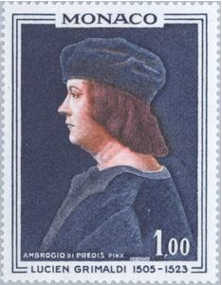
22 Aug 1523 - 7 Oct 1581 Onorato I (= Honoré I) (b. 1522 - d. 1581)
22 Aug 1523 - 14 Apr 1532 Agostino Grimaldi, vescovo
de Grasse –Regent (b. 1479 - d. 1532)
14 Apr 1532 - Jun 1532 Bianca Grimaldi, baronessa
di Tourettes (f) -Regent (b. 148. - d. 1540)
Jun 1532 - 6 Dec 1540 Stefano Grimaldi, barone
di Bueil –Regent (d. 1561)
7 Oct 1581 - 17 May 1589 Carlo II (= Charles II) (b. 1555 - d. 1589)
17 May 1589 - 21 Nov 1604 Ercole (= Hercule) (b. 1562 - d. 1604)
21 Nov 1604 - 14 Sep 1641 Onorato II (= Honoré II) (b. 1597 - d. 1662)
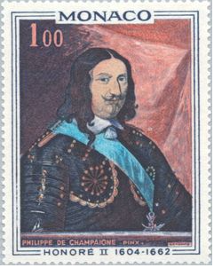
21 Nov 1604 - c.Feb 1616 Federico, principe Landi (b. 1589 - d. 1633)
di Valditaro -Regent
Princes¹
14 Sep 1641 - 10 Jan 1662 Onorato II (= Honoré II) (s.a.)
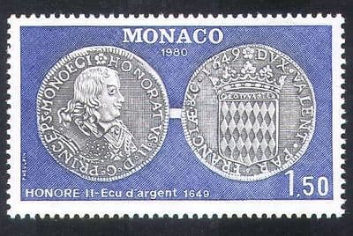
10 Jan 1662 - 2 Jan 1701 Luigi (= Louis I) (b. 1642 - d. 1701)
3 Jan 1701 - 20 Feb 1731 Antonio (= Antoine I) (b. 1661 - d. 1731)
21 Feb 1731 - 29 Dec 1731 Luigia Ippolita -Princess
(= Louise-Hippolyte) (b. 1697 - d. 1731)

- Grimaldi dynasty¹ -
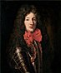 | 10 Jan 1662 - 2 Jan 1701 Louis I  (b. 1642 - d. 1701)
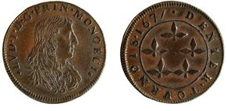
 |  | 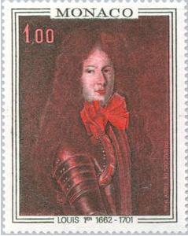
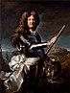 | 2 Jan 1701 - 20 Feb 1731 Antoine I  (b. 1661 - d. 1731)
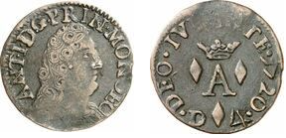
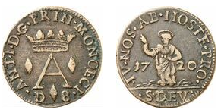
 |  | 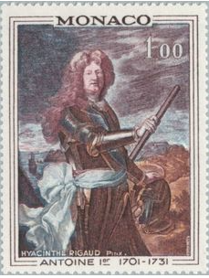
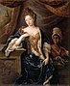 | 20 Feb 1731 - 31 Dec 1731 Louise-Hippolyte (f)  (b. 1697 - d. 1731)
 |  | 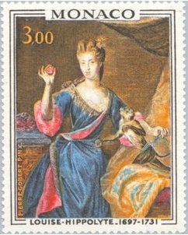
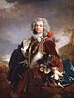 | 20 Feb 1731 - 7 Nov 1733 Jacques I  (b. 1689 - d. 1751) (regent to 31 Dec 1731)
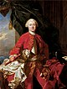 | 7 Nov 1733 - 14 Feb 1793 Honoré III  (b. 1720 - d. 1795)
 |  | 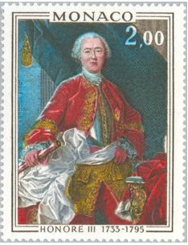
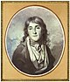 | 30 May 1814 - 16 Feb 1819 Honoré IV  (b. 1758 - d. 1819)
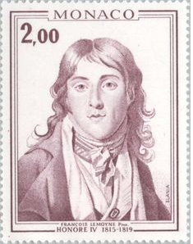
3 Jun 1814 - 18 Jan 1815 Joseph (regent)
(b. 1763 - d. 1816)
18 Jan 1815 - 16 Feb 1819 Honoré (regent)
(b. 1778 - d. 1841)
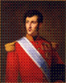 | 16 Feb 1819 - 2 Oct 1841 Honoré V (s.a.)
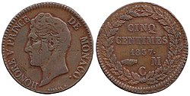
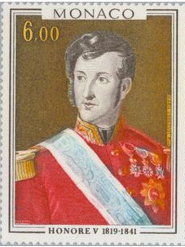
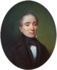 | 2 Oct 1841 - 20 Jun 1856 Florestan I  (b. 1785 - d. 1856)
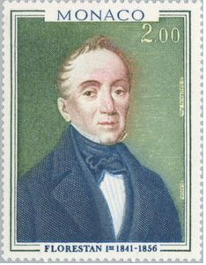
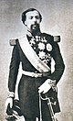 | 20 Jun 1856 - 10 Sep 1889 Charles III  (b. 1818 - d. 1889)
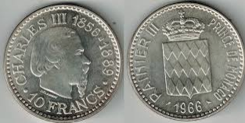
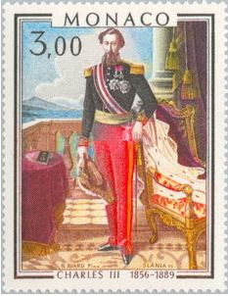 |  | 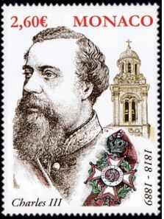
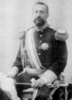 | 10 Sep 1889 - 26 Jun 1922 Albert I  (b. 1848 - d. 1922)
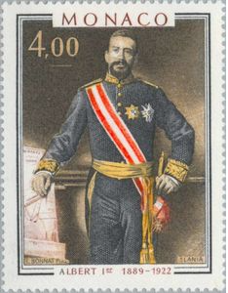 |  | 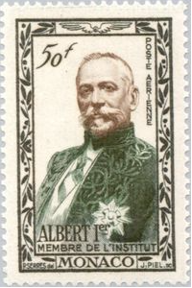
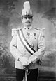 | 26 Jun 1922 - 9 May 1949 Louis II  (b. 1870 - d. 1949)
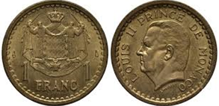
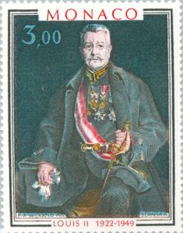 |  | 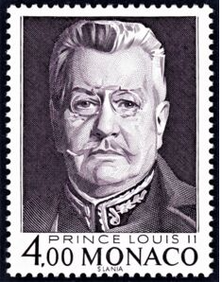
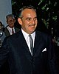 | 9 May 1949 - 6 Apr 2005 Rainier III  (b. 1923 - d. 2005)
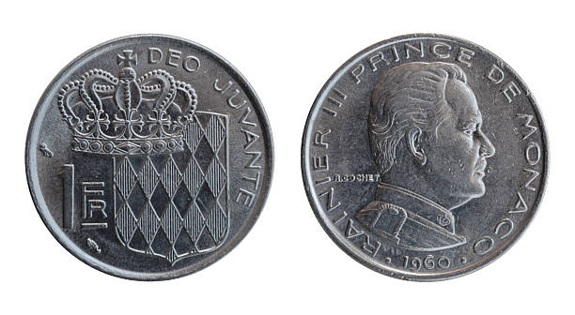
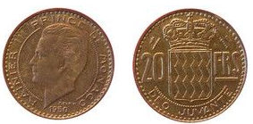
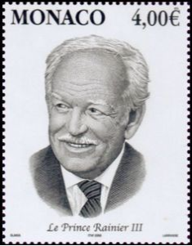
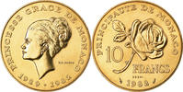
31 Mar 2005 - 6 Apr 2005 Albert (regent)
(b. 1958)
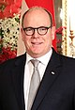 | 6 Apr 2005 - Albert II (s.a.)
 |  | 

President of the National Convention (Président de la Convention Nationale)
19 Jan 1793 - 4 Mar 1793 Joseph Augustin Marie Barriera, (b. 1741 - d. 1819)
dit Barriera aîné
(Joseph Augustin Marie Barriera)
(= Giuseppe Agostino Maria Barriera)
Commander-in-chief of the Army of the French Republic in Italy
24 Feb 1793 - 1 Mar 1793 Armand Louis de Gontaut, duc (b. 1747 - d. 1793)
de Lauzun
Commissioners of the French National Convention
1 Mar 1793 - 4 Mar 1793 Baptiste-Henry Grégoire (b. 1750 - d. 1831)
+ Grégoire Marie Jagot (b. 1750 - d. 1838)
President of the Provisional Administration
4 Mar 1793 - May 1793 Paul Imberti (= Paolo Imberti)
Austrian and Sardinian Commanders
12 May 1800 - 31 May 1800 cavaliere Fulchieri (Sardinian commander)
+ Hungher (Austrian commissioner)
Allied Military Commander
17 May 1814 - 1814 Ritter von Baur (Austria)
President of the Provisional Government
17 Apr 1814 - 17 Jun 1814 Pierre Antoine Marie Louis (b. 1755 - d. 1828)
Gonzague de Millo Terrazzani
(= Pietro Antonio Maria Luigi Gonzaga)
Princes¹
17 Jun 1814 - 16 Feb 1819 Honoré IV (b. 1758 - d. 1819)
17 Jun 1814 - 3 Mar 1815 Joseph Marie Jerôme Honoré (b. 1763 - d. 1816)
Grimaldi -Regent
(administrator-general)
3 Mar 1815 - 16 Feb 1819 Honoré Grimaldi, duc de (b. 1778 - d. 1841)
Valentinois -Regent
(administrator-general)
13 Mar 1815 - Jun 1815 Francis Burke -British commander
16 Feb 1819 - 2 Oct 1841 Honoré V (= Honoré Grimaldi) (s.a.)
2 Oct 1841 - 20 Jun 1856 Florestan I (b. 1785 - d. 1856)
23 Mar 1848 - 20 Jun 1856 Charles Honoré Grimaldi -Regent (b. 1818 - d. 1889)
(administrator-general)
20 Jun 1856 - 10 Sep 1889 Charles III (s.a.)
(= Charles Honoré Grimaldi)
10 Sep 1889 - 26 Jun 1922 Albert I (b. 1848 - d. 1922)
26 Jun 1922 - 9 May 1949 Louis II (b. 1870 - d. 1949)
9 May 1949 - 6 Apr 2005 Rainier III (b. 1923 - d. 2005)
31 Mar 2005 - 6 Apr 2005 Prince Albert -Regent (b. 1958)
6 Apr 2005 - Albert II (s.a.)
Governors-general
20 May 1732 - 28 Nov 1784 Antoine Charles, chevalier de (b. 1697 - d. 1784)
Grimaldi
28 Nov 1784 - 24 May 1785 Pierre Antoine Alexandre d'Adhémar (b. 1730 - d. 1785)
de Lantagnac (acting)
1785 - 1786 Jean-Pierre de Meyronnet, baron (b. 1745 - d. 1817)
de Saint-Marc
1786 - 1787 Gaston François de Brueys, (b. 1743 - d. 1806)
baron d'Aigalliers
1787 - 1789 Honoré Jérôme de Monléon (b. 1730 - d. 1809)
1789 - 24 Feb 1793 Horace Michel-Ange Nicolas Marie (b. 1751 - d. 1839)
Pretti de Saint-Ambroise
(1st time)
Maires (mayors) of Fort d'Hercule
24 Feb 1793 - 31 Mar 1793 Jean-Michel Alexandre de Millo (b. 1719 - d. 1794)
(1st time)
31 Mar 1793 - 8 Apr 1793 Jean Louis Lanciarès (Lanciarez) (b. 1738 - d. 1807)
(1st time) (acting)
8 Apr 1793 - May 1793 Jean-Michel Alexandre de Millo (s.a.)
(2nd time)
3 May 1793 - Jan 1795 Jean Louis Lanciarès (2nd time) (s.a.)
Jan 1795 - 1796? ... Rey
1796 - 1799 Joseph Barrière aîné (1st time) (s.a.)
1800 - 1802 Epiphane François Bellando (b. 1758 - d. 1827)
1802 - Feb 1804 Joseph Barrière aîné (2nd time) (s.a.)
Feb 1804 - May 1814 Charles Antoine Louis Philippe (b. 1748 - d. 1817)
de Sigaldi
Governors-general and Presidents of the Council of State
17 Jun 1814 - 22 Dec 1828 Pierre Antoine Marie Louis (s.a.)
Gonzague de Millo Terrazzani
22 Dec 1828 - 1829 .... (acting)
1829 - 16 Jan 1839 Horace Michel-Ange Nicolas Marie (s.a.)
Pretti de Saint-Ambroise
(2nd time)
16 Jan 1839 - 1839 .... (acting)
1839 - 18 Dec 1847 Charles-Athanase Rey, chevalier (b. 1780 - d. 1871) Mil
de Villarey
18 Dec 1847 - 26 Dec 1847 Adrien Marie Telespore Médecin (b. 1778 - d. 1847) Mil
(acting)
27 Dec 1847 - 1855 Antoine Alexandre Bellando (b. 1786 - d. 1877) Mil
(interim)
1855 - May 1857 .... (acting)
May 1857 - 1862 Jean André Gustave Malmazet, (b. 1800 - d. 1880)
comte de Saint-Andéol
21 May 1862 - 20 Jul 1874 Édouard, baron Imberty (b. 1806 - d. 1874)
(acting to ... 1862)
20 Jul 1874 - 27 Feb 1875 Léonce Joseph de Coye, chevalier (b. 1804 - d. 1881)
de Castellet (acting)
27 Feb 1875 - 14 Jan 1884 Charles Victor Émile de Boyer, (b. 1825 - d. 1884)
baron de Sainte-Suzanne
14 Jan 1884 - 7 Apr 1884 Marie Henri Louis Durand-Auzias (b. 1834 - d. 1894)
(acting)
7 Apr 1884 - 13 Jan 1887 François Flavien Alfred, baron (b. 1829 - d. c.1906)
de Saint-Priest
13 Jan 1887 - 18 Feb 1895 Louis Marie Anatole de Véron, (b. 1827 - d. 1904)
baron de Farincourt
18 Feb 1895 - 30 Jun 1906 Georges Marie Olivier Ritt (b. 1830 - d. 1911)
1 Jul 1906 - Jan 1909 Pierre Silvain Edmond Henri Roger (b. 1856 - d. 1939)
15 Dec 1908 - 30 Jun 1909 François Roussel-Despierres (b. 1854 - d. 1940)
(acting [for Roger to Jan 1909])
1 Jul 1909 - 4 Feb 1911 Marc Gilbert Paul Hautefeuille (b. 1852 - d. 1923)
15 Oct 1910 - 8 Feb 1911 Cirgues Antoine Georges Jaloustre (b. 1875 - d. 1922)
(acting [for Hautefeuille to 4 Feb 1911])
Ministers of state
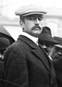 | 5 Feb 1911 - 31 Dec 1917 Émile Flach  (b. 1853 - d. 1926)
1 Jan 1918 - 22 Feb 1919 Georges Jaloustre (acting)
(b. 1875 - d. 1951)
22 Feb 1919 - 1 Oct 1923 Raymond Le Bourdon
(b. 1861 - d. 1937)
1 Oct 1923 - 12 Jan 1932 Maurice Piette
(b. 1871 - d. 1953)
12 Jan 1932 - 14 Jun 1932 Henry Mauran (1st time) (acting)
(b. 1876 - d. 1946)
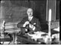 | 14 Jun 1932 - 22 May 1937 Maurice Bouilloux-Lafont  (b. 1875 - d. 1937)
 | 22 May 1937 - 1 Aug 1937 Henry Mauran (2nd time) (acting) (s.a.)
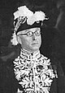 | 1 Aug 1937 - 29 Sep 1944 Émile Roblot  (b. 1886 - d. 1963)
29 Sep 1944 - 13 Oct 1944 Pierre Blanchy (1st time) (acting)
(b. ... - d. 1981)
13 Oct 1944 - 31 Dec 1948 Pierre de Witasse
(b. 1878 - d. 1956)
31 Dec 1948 - 12 Jul 1949 Pierre Blanchy
(2nd time) (acting) (s.a.)
12 Jul 1949 - 1 Aug 1950 Jacques Léon Rueff
(b. 1896 - d. 1978)
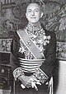 | 1 Aug 1950 - 2 Sep 1953 Pierre Voizard  (b. 1896 - d. 1982)
15 Nov 1953 - 31 Dec 1958 Henry Soum
(b. 1899 - d. 1983)
1 Jan 1959 - 12 Feb 1959 Pierre Blanchy
(3rd time) (acting) (s.a.)
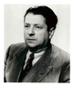 | 12 Feb 1959 - 23 Jan 1962 Émile Pelletier  (b. 1898 - d. 1975)
23 Jan 1962 - 16 Aug 1963 Pierre Blanchy
(4th time) (acting) (s.a.)
16 Aug 1963 - 28 Dec 1966 Jean Reymond
(b. 1912 - d. 1986)
28 Dec 1966 - 1 Apr 1969 Paul Demange
(b. 1906 - d. 1970)
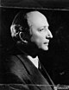 | 1 Apr 1969 - 24 May 1972 François-Didier Gregh  (b. 1906 - d. 1992)
24 May 1972 - 13 Jul 1981 André Saint-Mleux
(b. 1920 - d. 2012)
13 Jul 1981 - 16 Sep 1985 Jean Herly
(b. 1920 - d. 1998)
16 Sep 1985 - 16 Feb 1991 Jean Ausseil
(b. 1925 - d. 2001)
16 Feb 1991 - 2 Dec 1994 Jacques Dupont
(b. 1929 - d. 2002)
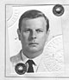 | 2 Dec 1994 - 3 Feb 1997 Paul Dijoud  (b. 1938)
3 Feb 1997 - 1 Jan 2000 Michel Lévêque
(b. 1933)
1 Jan 2000 - 1 Jun 2005 Patrick Leclercq
(b. 1938)
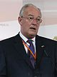 | 1 Jun 2005 - 29 Mar 2010 Jean-Paul Proust  (b. 1940 - d. 2010)
29 Mar 2010 - 1 Feb 2016 Michel Roger
(b. 1949)
16 Dec 2015 - 1 Feb 2016 Gilles Tonelli
(b. 1957)
(acting for Roger)
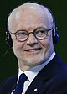 | 1 February 2016 – 31 August 2020 Serge Telle  (b. 1955)
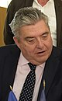 | 1 September 2020 - Pierre Dartout  (born 9 April 1954)
Italian Consuls in Monaco
1940 - 1941 Antonio Sanfelice (b. 1904 - d. 1970) PNF
1941 - 1943 Stanislao, marchese dei Lepri (b. 1905 - d. 1980) PNF
Commander of Italian forces (58th Infantry Division Legnano)
Nov 1942 - 9 Sep 1943 Vincenzo Cesare Dapino (b. 1891 - d. 1957)
German Consul General
5 Apr 1943 - 3 Sep 1944 Walter Hellenthal (b. 1896 - d. 1969) NSDAP
Commanders of German forces
- 60th Panzergrenadier division Feldherrnhalle -
9 Sep 1943 - Oct 1943 Otto Kohlermann (b. 1896 - d. 1984)
- 715th Infantry -
9 Sep 1943 - 5 Jan 1944 Kurt Hoffmann (b. 1890 - d. 1981)
5 Jan 1944 - Feb 1944 Hans-Georg Hildebrandt (b. 1896 - d. 1967)
- 148th Reserve division -
Feb 1944 - 20 Mar 1944 Otto Fretter-Pico (b. 1893 - d. 1966)
20 Mar 1944 - 3 Sep 1944 Otto Schönherr (b. 1888 - d. 1954)
¹Full style of the ruler:
(a) 20 Sep 1331 - 14 Sep 1641: (in Latin) Dominus et signoriae de Monaco, (from 1346) Mentone et (from 1355) Roccabruna; (in Italian) Signore di Monaco, (from 1346) Mentone (from 1355) e Roccabruna ("Lord of Monaco, [from 1346] Menton [from 1355] and Roquebrunne");
(b) 14 Sep 1641 - 13 Jan 1793: (in Italian) Per grazia di Dio Principe/Principessa Sovrano/Sovrana di Monaco, (in French): Par la grâce de Dieu, Prince/Princesse Souverain/Souveraine de Monaco ("By the grace of God, Sovereign Prince/Princess of Monaco"), long form Principe/Principessa Sovrano/Sovrana di Monaco, Signore/Signora Sovrano/Sovrana di Mentone e Roccabruna ("Sovereign Prince/Princess of Monaco, Sovereign Lord/Lady of Menton and Roquebrunne");
(c) from 30 May 1814: Par la grâce de Dieu, Prince Souverain de Monaco ("By the grace of God, Sovereign Prince of Monaco").
The dynastic name has been preserved through several changes in patrilineage: all males marrying female heirs to the principality (as i.e. the father of Rainier III) have changed their family name to Grimaldi. All princes since Jacques I carried the additional title of duc de Valentinois (from 18 Jul 1642), together with a very long list of other (actually extinct) titles: duc de Estouteville (from 23 Apr 1751), duc de Mazarin et de Mayenne (from 13 Dec 1826), prince de Château-Porcien (from 13 Dec 1826), marquis des Baux (from 14 Mar 1643), Chilly et Guiscard (from 13 Dec 1826), comte de Carladès (from 14 Mar 1643), Longjumeau, Thann, Belfort, Rosemont, Ferrette et de Thorigny (from 13 Dec 1826), baron de Calvinet (from 2 May 1642), Buis-les-Baronnies (from 23 Apr 1751), Hambie, Massy, Altkirch, Saint-Lô et de la Luthumière (from 13 Dec 1826), seigneur de Saint Rémy de Provence (from 23 May 1642) et Issenheim (from 13 Dec 1826) et sire di Matignon (from 23 Apr 1751).
Party abbreviations: UM = Union pour Monaco (Union for Monaco, centrist coalition incl. UNAM, est.2002); UNAM = Union Nationale pour l'Avenir de Monaco (National Union for the Future of Monaco, est.2002); UND = Union Nationale Démocratique (National Democratic Union, conservative, govt. majority 1963-1993, 1998-2003, renamed Rassemblement et Enjeux [Rally and Issues]); Mil = Military;
- Former parties: FTP = Francs-Tireurs et Partisans Français (French Irregular Riflemen and Partisans, communist dominated partisan resistance, 1940-1945); NSDAP = Nationalsozialistische Deutsche Arbeiterpartei (National Socialist German Workers' Party, Nazi German fascist, xenophobic, 1920-1945); PNF = Partito Nazionale Fascista (National Fascist Party, Italian fascist, nationalist, authoritarian, 1921-27 Jul 1943, successor Partito Fascista Repubblicano)

INCLUDEPICTURE "http://t0.gstatic.com/images?q=tbn:ANd9GcTDT1jpfS6n_Y4NmsXFnf0dV2uAk854tEHeOSaIXPxUCt7qxHu5xaSaZA" \* MERGEFORMATINET INCLUDEPICTURE "http://t0.gstatic.com/images?q=tbn:ANd9GcTDT1jpfS6n_Y4NmsXFnf0dV2uAk854tEHeOSaIXPxUCt7qxHu5xaSaZA" \* MERGEFORMATINET INCLUDEPICTURE "http://t0.gstatic.com/images?q=tbn:ANd9GcTDT1jpfS6n_Y4NmsXFnf0dV2uAk854tEHeOSaIXPxUCt7qxHu5xaSaZA" \* MERGEFORMATINET INCLUDEPICTURE "http://t0.gstatic.com/images?q=tbn:ANd9GcTDT1jpfS6n_Y4NmsXFnf0dV2uAk854tEHeOSaIXPxUCt7qxHu5xaSaZA" \* MERGEFORMATINET INCLUDEPICTURE "http://t0.gstatic.com/images?q=tbn:ANd9GcTDT1jpfS6n_Y4NmsXFnf0dV2uAk854tEHeOSaIXPxUCt7qxHu5xaSaZA" \* MERGEFORMATINET INCLUDEPICTURE "http://t0.gstatic.com/images?q=tbn:ANd9GcTDT1jpfS6n_Y4NmsXFnf0dV2uAk854tEHeOSaIXPxUCt7qxHu5xaSaZA" \* MERGEFORMATINET INCLUDEPICTURE "http://t0.gstatic.com/images?q=tbn:ANd9GcTDT1jpfS6n_Y4NmsXFnf0dV2uAk854tEHeOSaIXPxUCt7qxHu5xaSaZA" \* MERGEFORMATINET INCLUDEPICTURE "http://t0.gstatic.com/images?q=tbn:ANd9GcTDT1jpfS6n_Y4NmsXFnf0dV2uAk854tEHeOSaIXPxUCt7qxHu5xaSaZA" \* MERGEFORMATINET INCLUDEPICTURE "http://t0.gstatic.com/images?q=tbn:ANd9GcTDT1jpfS6n_Y4NmsXFnf0dV2uAk854tEHeOSaIXPxUCt7qxHu5xaSaZA" \* MERGEFORMATINET INCLUDEPICTURE "http://t0.gstatic.com/images?q=tbn:ANd9GcTDT1jpfS6n_Y4NmsXFnf0dV2uAk854tEHeOSaIXPxUCt7qxHu5xaSaZA" \* MERGEFORMATINET INCLUDEPICTURE "http://t0.gstatic.com/images?q=tbn:ANd9GcTDT1jpfS6n_Y4NmsXFnf0dV2uAk854tEHeOSaIXPxUCt7qxHu5xaSaZA" \* MERGEFORMATINET INCLUDEPICTURE "http://t0.gstatic.com/images?q=tbn:ANd9GcTDT1jpfS6n_Y4NmsXFnf0dV2uAk854tEHeOSaIXPxUCt7qxHu5xaSaZA" \* MERGEFORMATINET INCLUDEPICTURE "http://t0.gstatic.com/images?q=tbn:ANd9GcTDT1jpfS6n_Y4NmsXFnf0dV2uAk854tEHeOSaIXPxUCt7qxHu5xaSaZA" \* MERGEFORMATINET INCLUDEPICTURE "http://t0.gstatic.com/images?q=tbn:ANd9GcTDT1jpfS6n_Y4NmsXFnf0dV2uAk854tEHeOSaIXPxUCt7qxHu5xaSaZA" \* MERGEFORMATINET INCLUDEPICTURE "http://t0.gstatic.com/images?q=tbn:ANd9GcTDT1jpfS6n_Y4NmsXFnf0dV2uAk854tEHeOSaIXPxUCt7qxHu5xaSaZA" \* MERGEFORMATINET INCLUDEPICTURE "http://t0.gstatic.com/images?q=tbn:ANd9GcTDT1jpfS6n_Y4NmsXFnf0dV2uAk854tEHeOSaIXPxUCt7qxHu5xaSaZA" \* MERGEFORMATINET INCLUDEPICTURE "http://t0.gstatic.com/images?q=tbn:ANd9GcTDT1jpfS6n_Y4NmsXFnf0dV2uAk854tEHeOSaIXPxUCt7qxHu5xaSaZA" \* MERGEFORMATINET INCLUDEPICTURE "http://t0.gstatic.com/images?q=tbn:ANd9GcTDT1jpfS6n_Y4NmsXFnf0dV2uAk854tEHeOSaIXPxUCt7qxHu5xaSaZA" \* MERGEFORMATINET INCLUDEPICTURE "http://t0.gstatic.com/images?q=tbn:ANd9GcTDT1jpfS6n_Y4NmsXFnf0dV2uAk854tEHeOSaIXPxUCt7qxHu5xaSaZA" \* MERGEFORMATINET INCLUDEPICTURE "http://t0.gstatic.com/images?q=tbn:ANd9GcTDT1jpfS6n_Y4NmsXFnf0dV2uAk854tEHeOSaIXPxUCt7qxHu5xaSaZA" \* MERGEFORMATINET INCLUDEPICTURE "http://t0.gstatic.com/images?q=tbn:ANd9GcTDT1jpfS6n_Y4NmsXFnf0dV2uAk854tEHeOSaIXPxUCt7qxHu5xaSaZA" \* MERGEFORMATINET INCLUDEPICTURE "http://t0.gstatic.com/images?q=tbn:ANd9GcTDT1jpfS6n_Y4NmsXFnf0dV2uAk854tEHeOSaIXPxUCt7qxHu5xaSaZA" \* MERGEFORMATINET INCLUDEPICTURE "http://t0.gstatic.com/images?q=tbn:ANd9GcTDT1jpfS6n_Y4NmsXFnf0dV2uAk854tEHeOSaIXPxUCt7qxHu5xaSaZA" \* MERGEFORMATINET INCLUDEPICTURE "http://t0.gstatic.com/images?q=tbn:ANd9GcTDT1jpfS6n_Y4NmsXFnf0dV2uAk854tEHeOSaIXPxUCt7qxHu5xaSaZA" \* MERGEFORMATINET INCLUDEPICTURE "http://t0.gstatic.com/images?q=tbn:ANd9GcTDT1jpfS6n_Y4NmsXFnf0dV2uAk854tEHeOSaIXPxUCt7qxHu5xaSaZA" \* MERGEFORMATINET INCLUDEPICTURE "http://t0.gstatic.com/images?q=tbn:ANd9GcTDT1jpfS6n_Y4NmsXFnf0dV2uAk854tEHeOSaIXPxUCt7qxHu5xaSaZA" \* MERGEFORMATINET INCLUDEPICTURE "http://t0.gstatic.com/images?q=tbn:ANd9GcTDT1jpfS6n_Y4NmsXFnf0dV2uAk854tEHeOSaIXPxUCt7qxHu5xaSaZA" \* MERGEFORMATINET INCLUDEPICTURE "http://t0.gstatic.com/images?q=tbn:ANd9GcTDT1jpfS6n_Y4NmsXFnf0dV2uAk854tEHeOSaIXPxUCt7qxHu5xaSaZA" \* MERGEFORMATINET INCLUDEPICTURE "http://t0.gstatic.com/images?q=tbn:ANd9GcTDT1jpfS6n_Y4NmsXFnf0dV2uAk854tEHeOSaIXPxUCt7qxHu5xaSaZA" \* MERGEFORMATINET INCLUDEPICTURE "http://t0.gstatic.com/images?q=tbn:ANd9GcTDT1jpfS6n_Y4NmsXFnf0dV2uAk854tEHeOSaIXPxUCt7qxHu5xaSaZA" \* MERGEFORMATINET INCLUDEPICTURE "http://t0.gstatic.com/images?q=tbn:ANd9GcTDT1jpfS6n_Y4NmsXFnf0dV2uAk854tEHeOSaIXPxUCt7qxHu5xaSaZA" \* MERGEFORMATINET INCLUDEPICTURE "http://t0.gstatic.com/images?q=tbn:ANd9GcTDT1jpfS6n_Y4NmsXFnf0dV2uAk854tEHeOSaIXPxUCt7qxHu5xaSaZA" \* MERGEFORMATINET INCLUDEPICTURE "http://t0.gstatic.com/images?q=tbn:ANd9GcTDT1jpfS6n_Y4NmsXFnf0dV2uAk854tEHeOSaIXPxUCt7qxHu5xaSaZA" \* MERGEFORMATINET INCLUDEPICTURE "http://t0.gstatic.com/images?q=tbn:ANd9GcTDT1jpfS6n_Y4NmsXFnf0dV2uAk854tEHeOSaIXPxUCt7qxHu5xaSaZA" \* MERGEFORMATINET INCLUDEPICTURE "http://t0.gstatic.com/images?q=tbn:ANd9GcTDT1jpfS6n_Y4NmsXFnf0dV2uAk854tEHeOSaIXPxUCt7qxHu5xaSaZA" \* MERGEFORMATINET INCLUDEPICTURE "http://t0.gstatic.com/images?q=tbn:ANd9GcTDT1jpfS6n_Y4NmsXFnf0dV2uAk854tEHeOSaIXPxUCt7qxHu5xaSaZA" \* MERGEFORMATINET INCLUDEPICTURE "http://t0.gstatic.com/images?q=tbn:ANd9GcTDT1jpfS6n_Y4NmsXFnf0dV2uAk854tEHeOSaIXPxUCt7qxHu5xaSaZA" \* MERGEFORMATINET INCLUDEPICTURE "http://t0.gstatic.com/images?q=tbn:ANd9GcTDT1jpfS6n_Y4NmsXFnf0dV2uAk854tEHeOSaIXPxUCt7qxHu5xaSaZA" \* MERGEFORMATINET INCLUDEPICTURE "http://t0.gstatic.com/images?q=tbn:ANd9GcTDT1jpfS6n_Y4NmsXFnf0dV2uAk854tEHeOSaIXPxUCt7qxHu5xaSaZA" \* MERGEFORMATINET INCLUDEPICTURE "http://t0.gstatic.com/images?q=tbn:ANd9GcTDT1jpfS6n_Y4NmsXFnf0dV2uAk854tEHeOSaIXPxUCt7qxHu5xaSaZA" \* MERGEFORMATINET INCLUDEPICTURE "http://t0.gstatic.com/images?q=tbn:ANd9GcTDT1jpfS6n_Y4NmsXFnf0dV2uAk854tEHeOSaIXPxUCt7qxHu5xaSaZA" \* MERGEFORMATINET INCLUDEPICTURE "http://t0.gstatic.com/images?q=tbn:ANd9GcTDT1jpfS6n_Y4NmsXFnf0dV2uAk854tEHeOSaIXPxUCt7qxHu5xaSaZA" \* MERGEFORMATINET INCLUDEPICTURE "http://t0.gstatic.com/images?q=tbn:ANd9GcTDT1jpfS6n_Y4NmsXFnf0dV2uAk854tEHeOSaIXPxUCt7qxHu5xaSaZA" \* MERGEFORMATINET

Menton and Roquebrune
19 Apr 1346 Lordship of Mentone (Menton) acquired by Monaco
(acquisition completed 1491).
2 Jan 1355 Roccabruna (Roquebrune) castle acquired by Monaco.
13 Nov 1428 Submission to Milan for Mentone by hommage.
19 Dec 1448 Mentone and Roccabruna made a fief of Savoia.
14 Feb 1793 - 30 May 1814 Annexed to France along with Monaco.
17 Jun 1814 Restored to the Principality of Monaco.
4 Nov 1847 - 25 Nov 1847 Public unrest in Menton (put down by requested Sardinia-Piedmont
intervention).
22 Feb 1848 Menton asks Sardinia-Piedmont for protection.
2 Mar 1848 Provisional government established in Menton.
21 Mar 1848 Menton and Roquebrune proclaim themselves free cities
(Città Libere di Mentone e Roccabruna/Villes Libres de Menton
et Roquebrune) under Sardinian protection and Grimaldi dynasty
is deposed and then banned on 28 May 1848.
3 Apr 1848 Menton occupied by Piedmont-Sardinia.
18 Sep 1848 Piedmont-Sardinia decrees that the cities temporarily are to be
governed according to Sardinian law.
1 May 1849 Sardinia places Menton and Roquebrune administratively under
the intendant general of Nice.
10 Nov 1849 Annexed by Sardinia-Piedmont.
24 Mar 1860 County of Nice (including Menton and Roquebrune) ceded to
France by Sardinia-Piedmont (effective 14 Jun 1860).
2 Feb 1861 Monaco cedes all rights to Menton and Roquebrune to France
(effective 12 Feb 1861).
Sardinian Commander
4 Nov 1847 - 2 Mar 1848 Claudio Gonnet (b. 1795 - d. 1866)
President of the Commission
2 Mar 1848 - 30 Apr 1848 Charles Trenca (b. 1801 - d. 1853)
President of the Government
30 Apr 1848 - 15 Oct 1848 Charles Trenca (s.a.)
Sardinian Extraordinary Commissioner in Menton and Roquebrune
18 Sep 1848 - 1 Jan 1849 Paolo Onorato Vigliani (b. 1814 - d. 1900)

INCLUDEPICTURE "http://t0.gstatic.com/images?q=tbn:ANd9GcTDT1jpfS6n_Y4NmsXFnf0dV2uAk854tEHeOSaIXPxUCt7qxHu5xaSaZA" \* MERGEFORMATINET INCLUDEPICTURE "http://t0.gstatic.com/images?q=tbn:ANd9GcTDT1jpfS6n_Y4NmsXFnf0dV2uAk854tEHeOSaIXPxUCt7qxHu5xaSaZA" \* MERGEFORMATINET INCLUDEPICTURE "http://t0.gstatic.com/images?q=tbn:ANd9GcTDT1jpfS6n_Y4NmsXFnf0dV2uAk854tEHeOSaIXPxUCt7qxHu5xaSaZA" \* MERGEFORMATINET INCLUDEPICTURE "http://t0.gstatic.com/images?q=tbn:ANd9GcTDT1jpfS6n_Y4NmsXFnf0dV2uAk854tEHeOSaIXPxUCt7qxHu5xaSaZA" \* MERGEFORMATINET INCLUDEPICTURE "http://t0.gstatic.com/images?q=tbn:ANd9GcTDT1jpfS6n_Y4NmsXFnf0dV2uAk854tEHeOSaIXPxUCt7qxHu5xaSaZA" \* MERGEFORMATINET INCLUDEPICTURE "http://t0.gstatic.com/images?q=tbn:ANd9GcTDT1jpfS6n_Y4NmsXFnf0dV2uAk854tEHeOSaIXPxUCt7qxHu5xaSaZA" \* MERGEFORMATINET INCLUDEPICTURE "http://t0.gstatic.com/images?q=tbn:ANd9GcTDT1jpfS6n_Y4NmsXFnf0dV2uAk854tEHeOSaIXPxUCt7qxHu5xaSaZA" \* MERGEFORMATINET INCLUDEPICTURE "http://t0.gstatic.com/images?q=tbn:ANd9GcTDT1jpfS6n_Y4NmsXFnf0dV2uAk854tEHeOSaIXPxUCt7qxHu5xaSaZA" \* MERGEFORMATINET INCLUDEPICTURE "http://t0.gstatic.com/images?q=tbn:ANd9GcTDT1jpfS6n_Y4NmsXFnf0dV2uAk854tEHeOSaIXPxUCt7qxHu5xaSaZA" \* MERGEFORMATINET INCLUDEPICTURE "http://t0.gstatic.com/images?q=tbn:ANd9GcTDT1jpfS6n_Y4NmsXFnf0dV2uAk854tEHeOSaIXPxUCt7qxHu5xaSaZA" \* MERGEFORMATINET INCLUDEPICTURE "http://t0.gstatic.com/images?q=tbn:ANd9GcTDT1jpfS6n_Y4NmsXFnf0dV2uAk854tEHeOSaIXPxUCt7qxHu5xaSaZA" \* MERGEFORMATINET INCLUDEPICTURE "http://t0.gstatic.com/images?q=tbn:ANd9GcTDT1jpfS6n_Y4NmsXFnf0dV2uAk854tEHeOSaIXPxUCt7qxHu5xaSaZA" \* MERGEFORMATINET INCLUDEPICTURE "http://t0.gstatic.com/images?q=tbn:ANd9GcTDT1jpfS6n_Y4NmsXFnf0dV2uAk854tEHeOSaIXPxUCt7qxHu5xaSaZA" \* MERGEFORMATINET INCLUDEPICTURE "http://t0.gstatic.com/images?q=tbn:ANd9GcTDT1jpfS6n_Y4NmsXFnf0dV2uAk854tEHeOSaIXPxUCt7qxHu5xaSaZA" \* MERGEFORMATINET INCLUDEPICTURE "http://t0.gstatic.com/images?q=tbn:ANd9GcTDT1jpfS6n_Y4NmsXFnf0dV2uAk854tEHeOSaIXPxUCt7qxHu5xaSaZA" \* MERGEFORMATINET INCLUDEPICTURE "http://t0.gstatic.com/images?q=tbn:ANd9GcTDT1jpfS6n_Y4NmsXFnf0dV2uAk854tEHeOSaIXPxUCt7qxHu5xaSaZA" \* MERGEFORMATINET INCLUDEPICTURE "http://t0.gstatic.com/images?q=tbn:ANd9GcTDT1jpfS6n_Y4NmsXFnf0dV2uAk854tEHeOSaIXPxUCt7qxHu5xaSaZA" \* MERGEFORMATINET INCLUDEPICTURE "http://t0.gstatic.com/images?q=tbn:ANd9GcTDT1jpfS6n_Y4NmsXFnf0dV2uAk854tEHeOSaIXPxUCt7qxHu5xaSaZA" \* MERGEFORMATINET INCLUDEPICTURE "http://t0.gstatic.com/images?q=tbn:ANd9GcTDT1jpfS6n_Y4NmsXFnf0dV2uAk854tEHeOSaIXPxUCt7qxHu5xaSaZA" \* MERGEFORMATINET INCLUDEPICTURE "http://t0.gstatic.com/images?q=tbn:ANd9GcTDT1jpfS6n_Y4NmsXFnf0dV2uAk854tEHeOSaIXPxUCt7qxHu5xaSaZA" \* MERGEFORMATINET INCLUDEPICTURE "http://t0.gstatic.com/images?q=tbn:ANd9GcTDT1jpfS6n_Y4NmsXFnf0dV2uAk854tEHeOSaIXPxUCt7qxHu5xaSaZA" \* MERGEFORMATINET INCLUDEPICTURE "http://t0.gstatic.com/images?q=tbn:ANd9GcTDT1jpfS6n_Y4NmsXFnf0dV2uAk854tEHeOSaIXPxUCt7qxHu5xaSaZA" \* MERGEFORMATINET INCLUDEPICTURE "http://t0.gstatic.com/images?q=tbn:ANd9GcTDT1jpfS6n_Y4NmsXFnf0dV2uAk854tEHeOSaIXPxUCt7qxHu5xaSaZA" \* MERGEFORMATINET INCLUDEPICTURE "http://t0.gstatic.com/images?q=tbn:ANd9GcTDT1jpfS6n_Y4NmsXFnf0dV2uAk854tEHeOSaIXPxUCt7qxHu5xaSaZA" \* MERGEFORMATINET INCLUDEPICTURE "http://t0.gstatic.com/images?q=tbn:ANd9GcTDT1jpfS6n_Y4NmsXFnf0dV2uAk854tEHeOSaIXPxUCt7qxHu5xaSaZA" \* MERGEFORMATINET INCLUDEPICTURE "http://t0.gstatic.com/images?q=tbn:ANd9GcTDT1jpfS6n_Y4NmsXFnf0dV2uAk854tEHeOSaIXPxUCt7qxHu5xaSaZA" \* MERGEFORMATINET INCLUDEPICTURE "http://t0.gstatic.com/images?q=tbn:ANd9GcTDT1jpfS6n_Y4NmsXFnf0dV2uAk854tEHeOSaIXPxUCt7qxHu5xaSaZA" \* MERGEFORMATINET INCLUDEPICTURE "http://t0.gstatic.com/images?q=tbn:ANd9GcTDT1jpfS6n_Y4NmsXFnf0dV2uAk854tEHeOSaIXPxUCt7qxHu5xaSaZA" \* MERGEFORMATINET INCLUDEPICTURE "http://t0.gstatic.com/images?q=tbn:ANd9GcTDT1jpfS6n_Y4NmsXFnf0dV2uAk854tEHeOSaIXPxUCt7qxHu5xaSaZA" \* MERGEFORMATINET INCLUDEPICTURE "http://t0.gstatic.com/images?q=tbn:ANd9GcTDT1jpfS6n_Y4NmsXFnf0dV2uAk854tEHeOSaIXPxUCt7qxHu5xaSaZA" \* MERGEFORMATINET INCLUDEPICTURE "http://t0.gstatic.com/images?q=tbn:ANd9GcTDT1jpfS6n_Y4NmsXFnf0dV2uAk854tEHeOSaIXPxUCt7qxHu5xaSaZA" \* MERGEFORMATINET INCLUDEPICTURE "http://t0.gstatic.com/images?q=tbn:ANd9GcTDT1jpfS6n_Y4NmsXFnf0dV2uAk854tEHeOSaIXPxUCt7qxHu5xaSaZA" \* MERGEFORMATINET INCLUDEPICTURE "http://t0.gstatic.com/images?q=tbn:ANd9GcTDT1jpfS6n_Y4NmsXFnf0dV2uAk854tEHeOSaIXPxUCt7qxHu5xaSaZA" \* MERGEFORMATINET INCLUDEPICTURE "http://t0.gstatic.com/images?q=tbn:ANd9GcTDT1jpfS6n_Y4NmsXFnf0dV2uAk854tEHeOSaIXPxUCt7qxHu5xaSaZA" \* MERGEFORMATINET INCLUDEPICTURE "http://t0.gstatic.com/images?q=tbn:ANd9GcTDT1jpfS6n_Y4NmsXFnf0dV2uAk854tEHeOSaIXPxUCt7qxHu5xaSaZA" \* MERGEFORMATINET INCLUDEPICTURE "http://t0.gstatic.com/images?q=tbn:ANd9GcTDT1jpfS6n_Y4NmsXFnf0dV2uAk854tEHeOSaIXPxUCt7qxHu5xaSaZA" \* MERGEFORMATINET INCLUDEPICTURE "http://t0.gstatic.com/images?q=tbn:ANd9GcTDT1jpfS6n_Y4NmsXFnf0dV2uAk854tEHeOSaIXPxUCt7qxHu5xaSaZA" \* MERGEFORMATINET INCLUDEPICTURE "http://t0.gstatic.com/images?q=tbn:ANd9GcTDT1jpfS6n_Y4NmsXFnf0dV2uAk854tEHeOSaIXPxUCt7qxHu5xaSaZA" \* MERGEFORMATINET INCLUDEPICTURE "http://t0.gstatic.com/images?q=tbn:ANd9GcTDT1jpfS6n_Y4NmsXFnf0dV2uAk854tEHeOSaIXPxUCt7qxHu5xaSaZA" \* MERGEFORMATINET INCLUDEPICTURE "http://t0.gstatic.com/images?q=tbn:ANd9GcTDT1jpfS6n_Y4NmsXFnf0dV2uAk854tEHeOSaIXPxUCt7qxHu5xaSaZA" \* MERGEFORMATINET INCLUDEPICTURE "http://t0.gstatic.com/images?q=tbn:ANd9GcTDT1jpfS6n_Y4NmsXFnf0dV2uAk854tEHeOSaIXPxUCt7qxHu5xaSaZA" \* MERGEFORMATINET INCLUDEPICTURE "http://t0.gstatic.com/images?q=tbn:ANd9GcTDT1jpfS6n_Y4NmsXFnf0dV2uAk854tEHeOSaIXPxUCt7qxHu5xaSaZA" \* MERGEFORMATINET INCLUDEPICTURE "http://t0.gstatic.com/images?q=tbn:ANd9GcTDT1jpfS6n_Y4NmsXFnf0dV2uAk854tEHeOSaIXPxUCt7qxHu5xaSaZA" \* MERGEFORMATINET

Compiler FLN

